English 438/538
Reading Animal Lives in a Posthuman Age
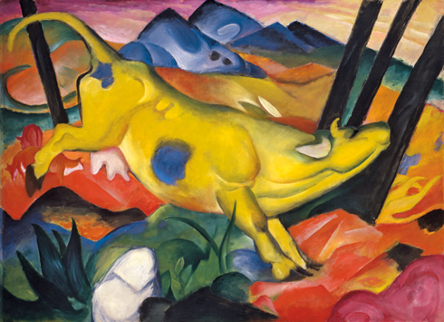
Spring 2017 Dr. Rashidian M/W 11:00-12:15
This course will focus on the new field in literary studies dedicated to the examination of our culture’s ideas about animal lives and where we as human beings stand in relation to those lives. A lot of work is being done to retrieve the histories of individual animals and species and to help us understand nonhuman subjectivities. The field contributes to a rethinking of how we share the planet with other living beings and sees nonhuman lives as having their own intrinsic worth. The specter of an impending great extinction has given added relevance to this new field. Our readings will explore our cultural ideas about animals, the new narratives of animal subjectivities and fictions that respond to anxieties caused by the threat of a sixth extinction. We’ll enter the discussion through a reading of Philip K. Dick’s Do Androids Dream of Electric Sheep. Readings will also include The Story of Edgar Sawtelle, excerpts from Jane Goodall’s writings, discussions of bioartists and animal photographers, and pet memoirs like Mark Doty’s Dog Years. For more information contact me: ziba@selu.edu

