Creole!

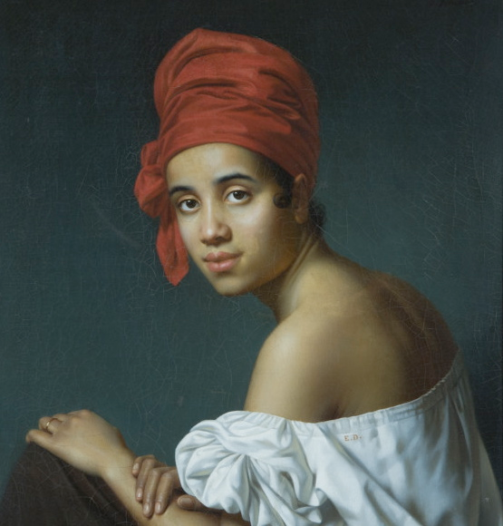

Louisiana Literature
English 439/539
Fall 2015: MW 12:30-1:45
Dr. Tom Fick

Exploring the disputed term "Creole" through poetry, fiction, non-fiction, film, and music, we will pay particular attention to the Afro-Creole community and its intersections with Anglo, white francophone Creole, Native American, and Cajun populations. Texts will address the fascinating ethnic gumbo of Louisiana and the formative debates over racial identity that have shaped American social and political discourse.

Authors: Victor Séjour Lyle Saxon
George Washington Cable Kate Chopin
Edward Laroque Tinker Charles Chesnutt
Ernest Gaines Anne Rice
Brenda Marie Osbey Tim Geautreaux
and Sybil Kein
Other topics:
Jelly Roll Morton Zydeco music
the Haitian Revolution quadroon balls
. . . a veritable feast!

