English 630
Dr. Tom Fick
Monday, 5:00-7:30

Promise(d) Land: The Confidence Game in American Literature and Culture

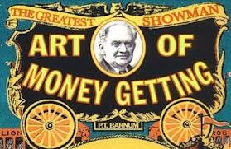

Literary and cultural critics have long called the confidence man a covert cultural hero. From the publication of Herman Melville’s novel The Confidence-Man: His Masquerade” in 1857 to Walter Kirn’s creative nonfiction work Blood Will Out: The True Story of a Murder, a Mystery, and a Masquerade (2014), the con man in his various guises has inspired some of our best writers, among them William Dean Howells, Mark Twain, Charles Chesnutt, Ralph Ellison, Flannery O’Connor, Ken Kesey, Jerzy Kosinski, Patricia Highsmith, and David Samuels. We’ll delve into these authors, watch some of the best con-man films (David Mamet’s “House of Games,” for example), and explore related issues: slight-of-hand, representative cultural figures like P. T. Barnum, and so forth.

