GENDER AND
AMERICAN CINEMA
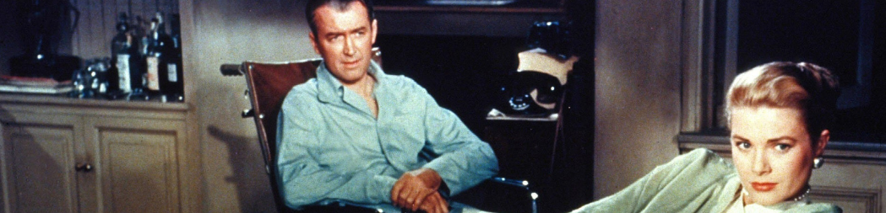

ENGL 429/527 | MW 3:30-4:45 | SPRING 2015

In this course, we will explore critical and theoretical approaches to questions of gender and film studies. Applying concepts from feminism, postfeminism, psychoanalysis, Marxism, and queer theory, we will investigate Hollywood’s gendered system of difference. We will begin the semester examining the Hollywood films that conform to Laura Mulvey’s foundational conception of the male gaze and then move on to look at how other films and directors challenge the male gaze through subtext, parody, and camp. Finally, we will end the semester by exploring contemporary trends in gender representation like the female action hero, the manic pixie dream girl, the comic book superhero, and the Bechdel test. Students will complete response papers, exams, a term paper, and a presentation.

SCREENINGS
Attack of the 50 Foot Woman (Nathan Juran, 1958)
The Dark Knight (Christopher Nolan, 2008)
Bernie (Richard Linklater, 2011)
Faster, Pussycat! Kill Kill! (Russ Meyer, 1965)
Fatal Attraction (Adrian Lyne, 1987)
Gentlemen Prefer Blondes (Howard Hawks, 1953)
Hanna (Joe Wright, 2011)
Heathers (Michael Lehman, 1988)
Rear Window (Alfred Hitchcock, 1954)
Scott Pilgrim vs. the World (Edgar Wright, 2010)
The Silence of the Lambs (Jonathan Demme, 1991)
The Wizard of Oz (Victor Fleming, 1939)

FOR MORE INFORMATION, CONTACT JASON LANDRUM AT JASON.LANDRUM@SELU.EDU

