MODERNISM: EUROPE 1890-1950
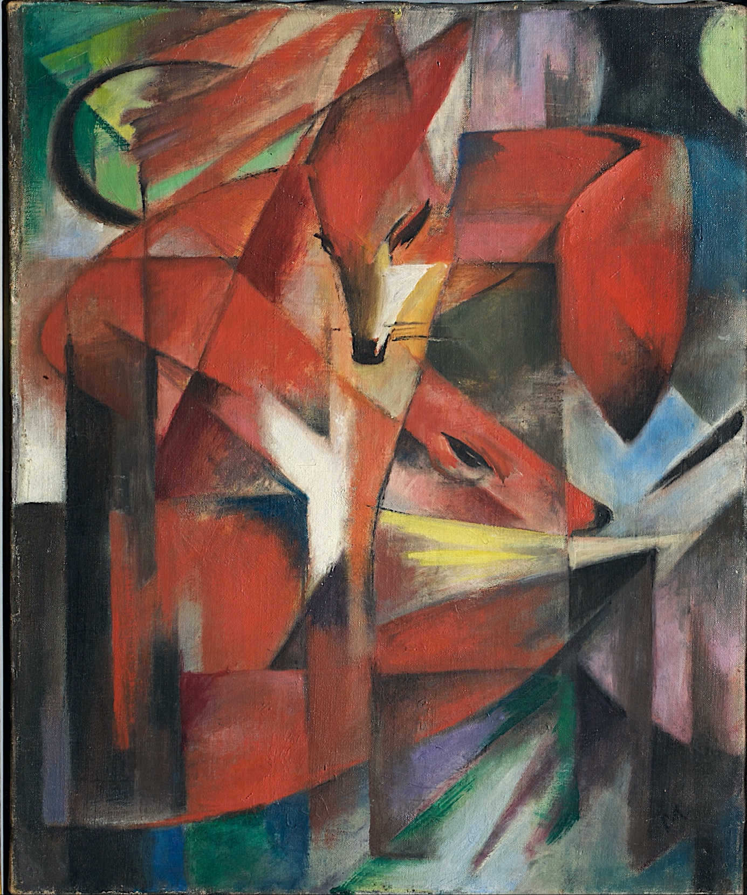
FRANZ MARC, THE FOXES 1913

This course will survey major movements in European Modernism, exploring poetry, visual arts, essays, drama, and three exemplary novels that encapsulate central preoccupations of writers and artists from the fin-de-siecle to the “late modernism” of Samuel Beckett.
ENGL 488/588 MW 2:00-3:15 DR. ZIBA RASHIDIAN

