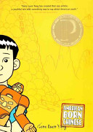
English 426/526
The Adolescent Experience in Literature
What do you like to read? What are your peers reading?
What’s new in the world of Young Adult Literature?
How do adolescents in the world cope with their challenges?
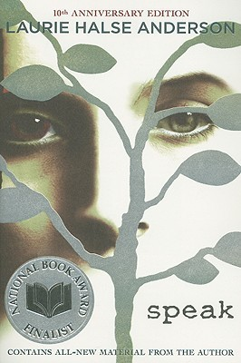
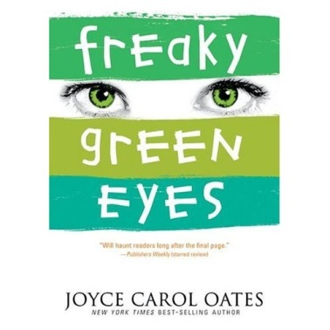
Sign up for English 426/526 in Spring 2022 and find out
Tuesdays and Thursdays from 11:00 till 12:15 p.m.
We will explore a number of realistic young adult fiction novels and make connections to timeless classics.
