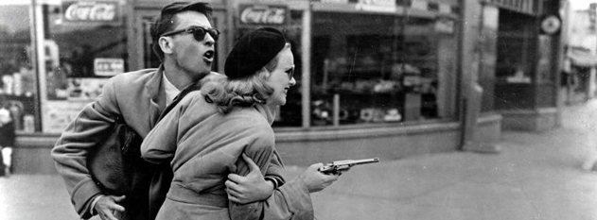
FILM NOIR

ENGL 610 | M 5:00-7:45PM | FALL 2016
In this course, we will engage in close analyses of a series of notoriously gritty, sexy, paranoid, and brazenly anti-humanist crime films collectively known as film noir. Difficult to define and endlessly debated, film noir is perhaps the most troublesome term to emerge out of Classical Hollywood. The term is problematic because the filmmakers working within its traditions had no clear sense that they were “doing noir” in the same way they understood they were making a Western or a gangster film. Many scholars refer to film noir as a genre, some call it a style, and others identify it as a cycle of films, but, more often than not, film noir fails to satisfy those looking for a thorough definition. The elusive nature of film noir should not, however, dissuade us from pursuing a definition. On the contrary, the impossibility of fully classifying film noir can help explain its persistence. Required weekly screenings will include classic American films noir such as The Maltese Falcon (1941), Double Indemnity (1944), and Kiss Me Deadly (1955), as well as neo-noirs such as Blade Runner (1982) and Memento (2000). Assignments such as a close reading essay, an annotated bibliography, a research essay, and a final exam will be required.

Yes, I killed him. I killed him for money—and a woman—and I didn't get the money and I didn't get the woman. Pretty, isn't it?
—Walter Neff,
Double Indemnity

For more information, contact Jason Landrum at jason.landrum@selu.edu.

