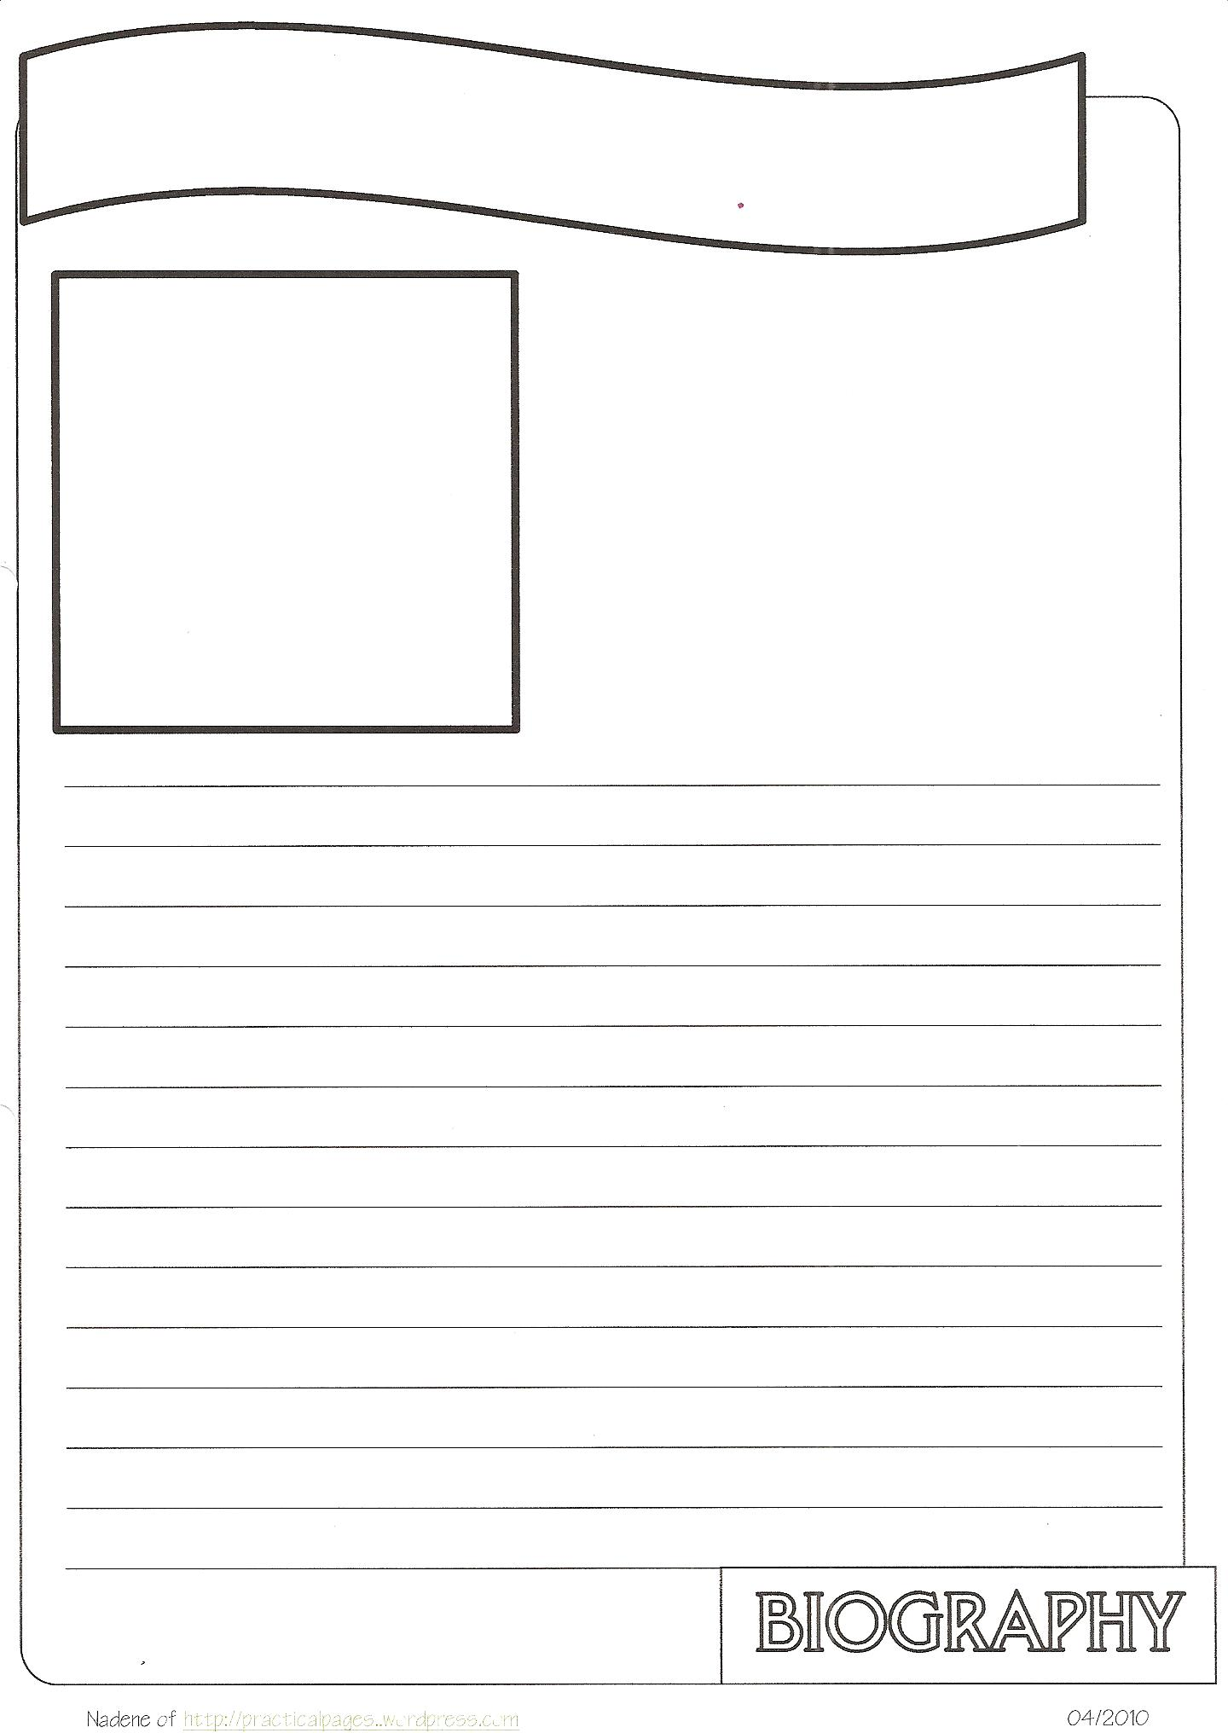
English 467/567 – The TEACHING of WRITING,
where writing becomes FUN

Tuesdays and Thursdays
from 3:30 till 4:45

Do you want to improve your writing or
learn some tricks about teaching it?

Then English 467/567 is a class for YOU.
Come and see what you CAN do!

